-- INNER JOIN-Employees + Department + Project-Only employees who HAVE a dept AND work on a project
SELECT E.SSN,
E.FName || ' ' || E.LName AS Employee_Name,
E.Gender,
E.HireDate,
D.DN AS Department_Name,
D.Loc AS Department_Location,
P.PN AS Project_Name,
P.City AS Project_City,
W.Hours AS Working_Hours
FROM EMPLOYEE E
JOIN DEPT D ON E.Dnum = D.Dnum
JOIN WORK_ON W ON E.SSN = W.EmpSSN
JOIN PROJECT P ON W.Pnum = P.Pnum
ORDER BY E.SSN;
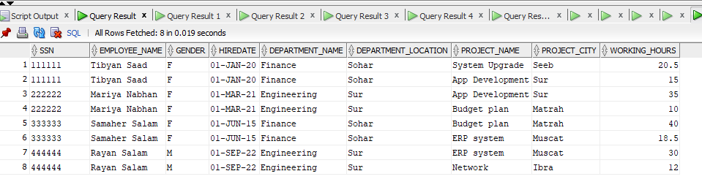

--LEFT JOIN
SELECT E.SSN,
E.FName || ' ' || E.LName AS Employee_Name,
E.Gender,
D.DN AS Department_Name,
D.Loc AS Department_Location,
NVL(DP.Dname, 'No Dependent') AS Dependent_Name,
NVL(DP.Gender, 'N/A') AS Dependent_Gender,
DP.BD AS Dependent_BirthDate
FROM EMPLOYEE E
LEFT JOIN DEPT D ON E.Dnum = D.Dnum
LEFT JOIN DEPENDENT DP ON E.SSN = DP.EmpSSN
ORDER BY E.SSN;
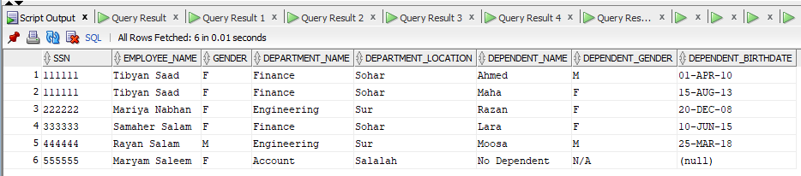

--RIGHT JOIN
SELECT P.Pnum,
P.PN AS Project_Name,
P.City AS Project_City,
D.DN AS Department_Name,
D.Loc AS Department_Location,
NVL(E.FName || ' ' || E.LName,
'No Employee Assigned') AS Employee_Name,
W.Hours AS Working_Hours
FROM EMPLOYEE E
RIGHT JOIN WORK_ON W ON E.SSN = W.EmpSSN
RIGHT JOIN PROJECT P ON W.Pnum = P.Pnum
RIGHT JOIN DEPT D ON P.Dnum = D.Dnum
ORDER BY P.Pnum;
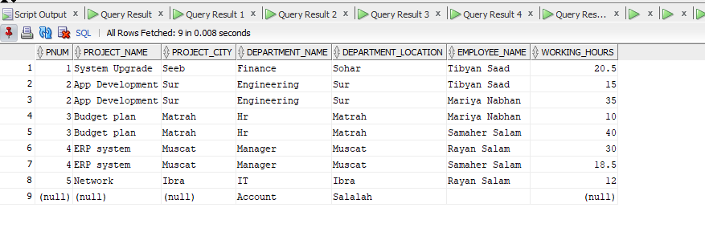
-- SELF JOIN
SELECT E.SSN AS Employee_SSN,
E.FName || ' ' || E.LName AS Employee_Name,
E.HireDate AS Hire_Date,
D.DN AS Department_Name,
NVL(S.FName || ' ' || S.LName,
'No Supervisor') AS Supervisor_Name,
NVL(S.SSN, 'N/A') AS Supervisor_SSN
FROM EMPLOYEE E
LEFT JOIN EMPLOYEE S ON E.SupperSSN = S.SSN
JOIN DEPT D ON E.Dnum = D.Dnum
ORDER BY E.SSN;
